1. One of the most important points of being a good developer is to develop a **testable app**.
2. Mockito plays a key role to develop such testable apps.
3. **Agenda**:
   1. What is **JUnit**?
   2. What is **Unit-Testing**?
   3. How can you do mocking with **Mockito**?
   4. How to write great **tests** with **Junit** & **Mockito**?
4. 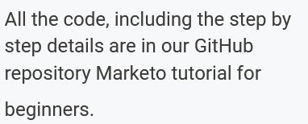

<https://github.com/in28minutes/JUnitIn28Minutes>  
<https://github.com/in28minutes/MockitoTutorialForBeginners>

1. 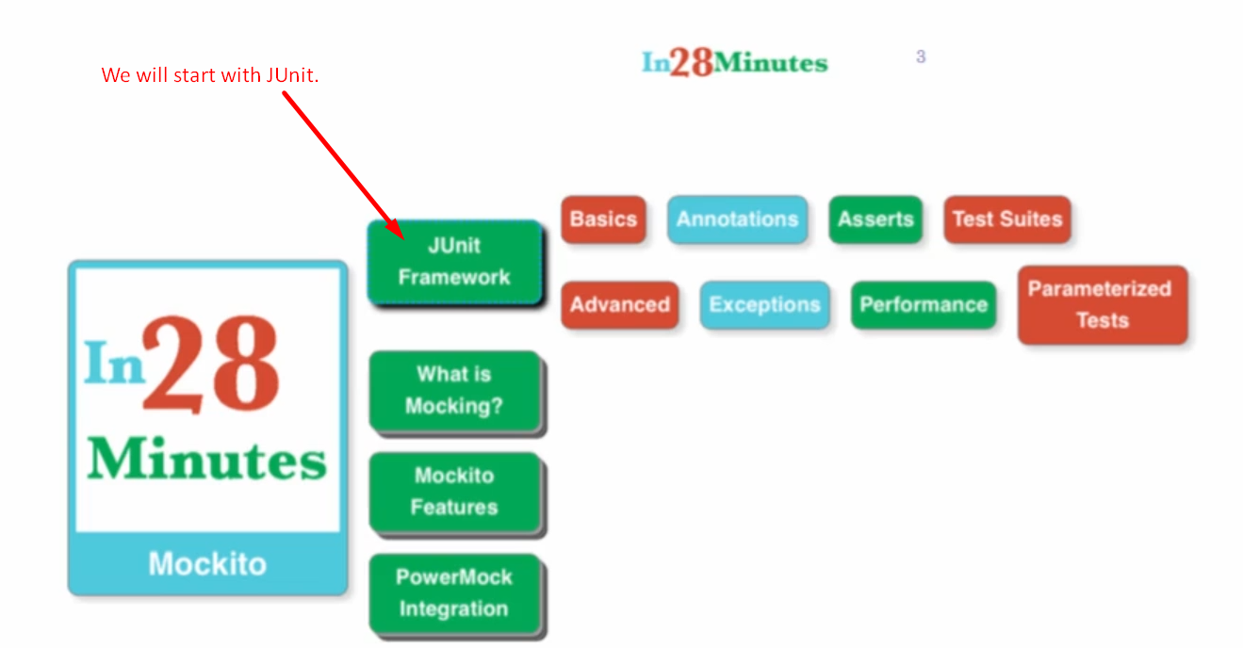
2. Diagram

   Description automatically generated
3. Graphical user interface, diagram

   Description automatically generated
4. 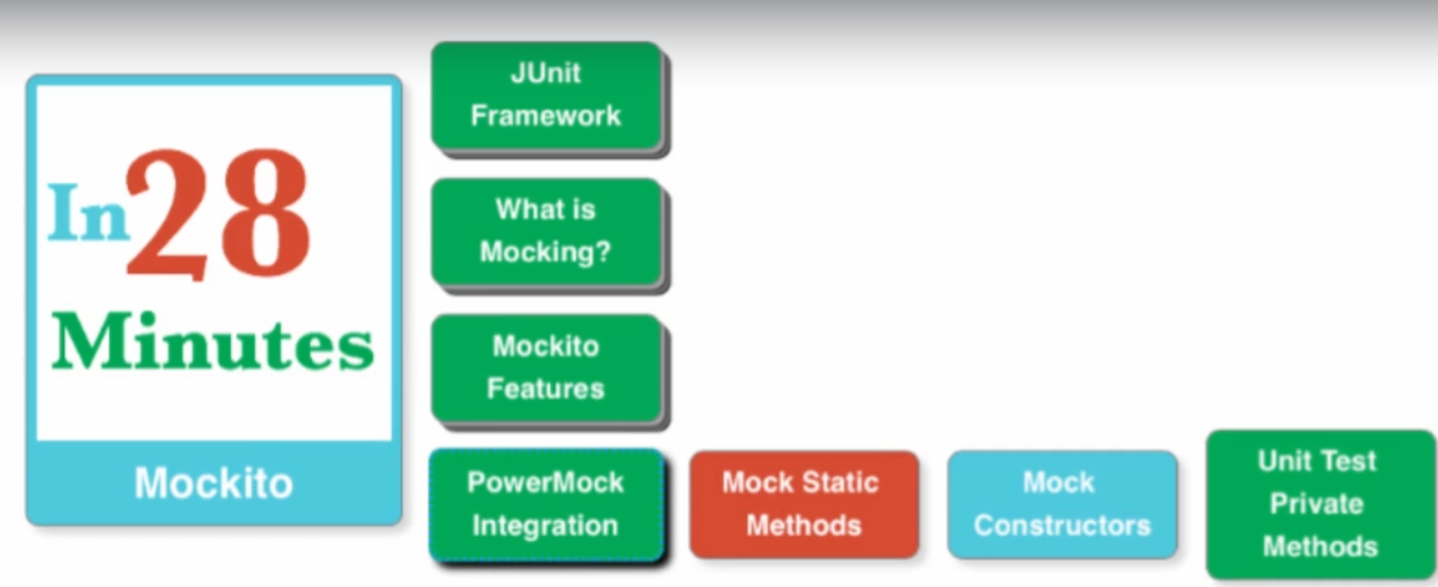
   1. We will integrate Mockito with **PowerMock** to be able to mock
      1. **Static Methods**
      2. **Constructors**.
      3. **Private Methods**.
5. **Pre-requisite:** 
   1. Only to be Good Java Programmer.